Modeling loan pricing and recorded outcomes
Calvin Baker | DX799 Module C | Milestone One | October 16, 2026

Project and questions
This project tests whether model complexity improves issued-rate prediction and recorded-outcome classification across three independent financial datasets. For a lending analytics stakeholder, its value is identifying defensible benchmarks and detecting misleading performance caused by recording artifacts or overfitting.
The questions concern pricing accuracy, classification ranking, and cutoff transfer. Weeks 5 and 6 receive the detailed treatment: support vector machines and decision trees with random forests. Weeks 1–4 supply the benchmarks. Results come from saved notebook outputs (Baker, 2026).

Data and exploratory findings
LendingClub uses accepted 2015 loans: regression explains issued rates; classification distinguishes Charged Off from Fully Paid among resolved 36-month loans. Loan_Default models observed positive rates or recorded Status 1, whose definition and observation window are undocumented. Bank outcomes are historical tenure or checking versus savings/CD accounts. They cannot be pooled as defaults.
Exploration changed the design. Skewed loan amounts and incomes motivated log transforms in the regression analysis. Redundant funding fields and FICO bounds prompted consolidation. A missing-rate rule attained 99.87% training accuracy on Loan_Default status, exposing a recording artifact; affected pricing and related fields were excluded from classification. Bank date checks retained 39 of 100 records at the fixed reference date September 26, 2026. Invalid, partial, future, or inconsistent dates were excluded; no SSNs were loaded.

Weeks 1 and 2 explain pricing with modest complexity
Week 1 compared additive ordinary least squares (OLS), polynomial curvature, and interactions that let associations depend on another predictor. Restricted candidate forms and validation root mean squared error (RMSE) limited overfitting. LendingClub validation RMSE fell from 3.120 to 3.107 percentage points (pp); Loan_Default fell from 0.451 to 0.440 pp. Bank interactions worsened error from 19.820 to 20.781 years, favoring additive ordinary least squares (OLS).
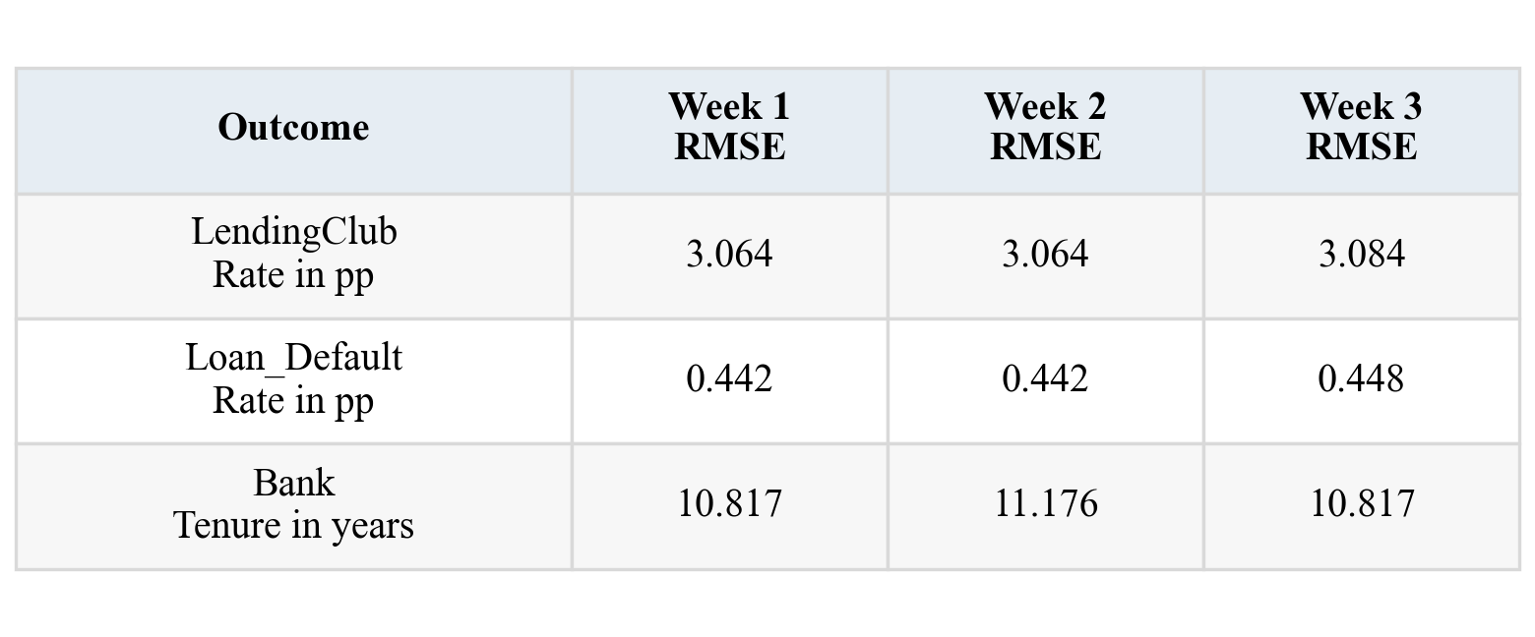
Figure 1. Test RMSE for the validation-selected model in each regression week. Loan test n = 4,800 per dataset; bank n = 8. Units differ by row. Source: Weeks 1–3.
Week 2 tested ridge L2, sparse lasso L1, and elastic net’s mixture. Larger alpha increases shrinkage; L1 ratio controls the mixture. Three-fold training cross-validation (CV) refitted preprocessing and tuned penalties. LendingClub selected lasso alpha 0.0046, retaining 26/27 terms; lasso and OLS test RMSE both rounded to 3.064 pp. The paired-bootstrap lasso-minus-OLS MAE interval [−0.0011, 0.0007] pp showed no clear gain. Loan_Default and bank selected OLS. Unexpectedly, regularization barely helped (scikit-learn developers, n.d.-a).

Weeks 3 and 4 test representation and probability models
Week 3 used forward/backward group selection, principal component regression (PCR), and partial least squares regression (PLSR), with training CV selecting subset/component counts. Groups preserve categorical indicators. PCR optimizes predictor variance; PLSR also uses the response. LendingClub retained 11/12 groups in both directions, all 24 PCR components, and 12 PLSR components. Forward selection test RMSE was 3.084 pp; Loan_Default’s was 0.448 pp. Bank selected full OLS. Full PCR reproduced OLS within numerical tolerance. Compression helped less than expected (scikit-learn developers, n.d.-c).
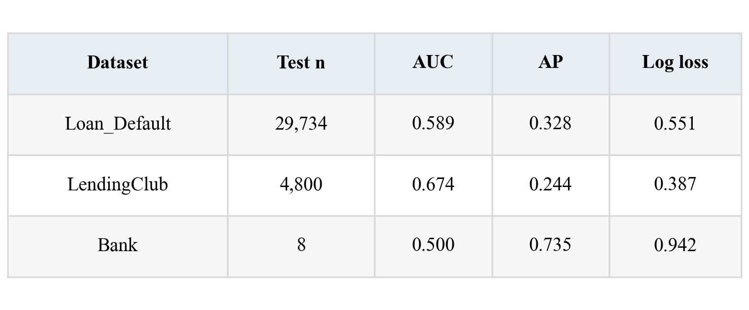
Figure 2. Week 4 logistic test results. AP is average precision, not accuracy. Positive prevalence was 24.6%, 14.3%, and 75.0%, respectively. Source: Week 4.
Week 4 compared unscaled, standard, min–max, and robust scaling in L2 logistic regression. Training CV tuned C; smaller C regularizes more. Validation log loss chose min–max/C = 10 for Loan_Default and standard/C = 0.1 for LendingClub, 0.01 for bank. At C = 1, standard scaling cut iterations from 134 to 43 and 3,000 to 117 for the loan datasets. LendingClub log loss beat its 0.410 baseline. Bank AUC remained 0.500: scaling cannot create signal (scikit-learn developers, n.d.-a, n.d.-b).

Week 5 in depth on kernels and regularization
A support vector machine (SVM) balances a wide separating margin against penalized violations. A linear kernel gives a linear boundary. The kernel trick computes similarities in richer feature spaces without explicitly constructing every transformed feature. Degree-two polynomial kernels capture interactions; RBF kernels use distance-based similarity. Extra flexibility can fit noise (scikit-learn developers, n.d.-d).
Larger C penalizes violations more strongly; smaller C regularizes more strongly. Larger RBF gamma makes influence more local. Week 5 searched linear/polynomial C {0.01, 0.1, 1} and RBF C {0.1, 1, 10} crossed with gamma {scale, 0.01}. Polynomial degree 2 and offset 1 were fixed. Gamma scale uses fitted input dimension and variance. Grid boundaries warrant further training-only search, not claims of global optimality.
Weeks 5–6 share 12,000-row loan samples and seed-42 stratified splits: 7,200 training, 2,400 validation, 2,400 test. LendingClub sampling scanned the full source. Bank splits contain 24/7/8 records, with accounts separated across partitions and three-fold CV. Fold-specific imputation, standardization, and full one-hot encoding prevent preprocessing leakage and arbitrary category distances.
Three-fold training CV selected parameters by ROC AUC; validation AUC selected the kernel. AUC measures ranking; AP emphasizes precision–recall and needs a prevalence reference. Validation F1 selected a score-quantile cutoff. Models and cutoffs were frozen without refitting to preserve score scale. SVM margins are not probabilities. Test results did not select another winner; validation selection remains optimistic.

Week 5 reveals weak ranking and cutoff transfer
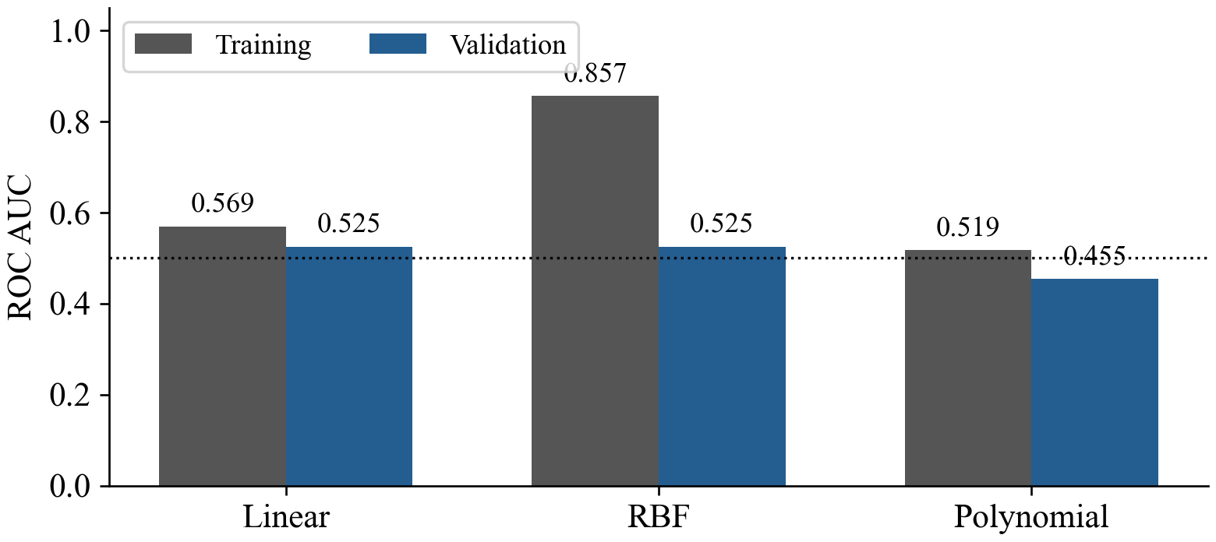
Figure 3. LendingClub SVM training and validation AUC after training CV tuning. The dotted line marks chance ranking. Training n = 7,200; validation n = 2,400. Source: Week 5.
Loan_Default selected RBF with C = 0.1 and gamma = scale. Validation AUC was 0.621, but test AUC was 0.590, essentially matching the fixed logistic baseline’s 0.591. LendingClub selected linear C = 0.1 by a very narrow validation margin. Its RBF model reached training AUC 0.857 but validation AUC 0.525 (Figure 3), showing that added flexibility did not generalize. The selected linear test AUC was 0.534, AP 0.172, and F1 0.239.
LendingClub’s default zero margin predicted no positives. The validation cutoff instead flagged 2,004 of 2,400 test loans, including 1,724 false positives. Threshold adjustment changed decisions but could not repair weak ranking. An always-positive rule would achieve F1 0.246 at the same 14.0% positive share, slightly above the selected rule. The bank polynomial model attained AUC 0.667 yet missed every checking account at its frozen cutoff.
These were unexpected failures of decision usefulness. A later balanced-linear sensitivity check improved validation AUC by 0.120 for Loan_Default and 0.114 for LendingClub. It tested class-specific penalties only on training and validation; it received no new test evaluation and does not replace the original findings. Class imbalance may contribute to weak unweighted margins, but this experiment does not prove the full cause.

Week 6 in depth on trees and overfitting
Trees split inputs to reduce Gini impurity. Depth caps limit successive rules, minimum leaf size prevents tiny groups, and cost-complexity pruning penalizes leaf count. Larger ccp_alpha favors smaller trees. These controls trade training fit for lower variance (scikit-learn developers, n.d.-e).
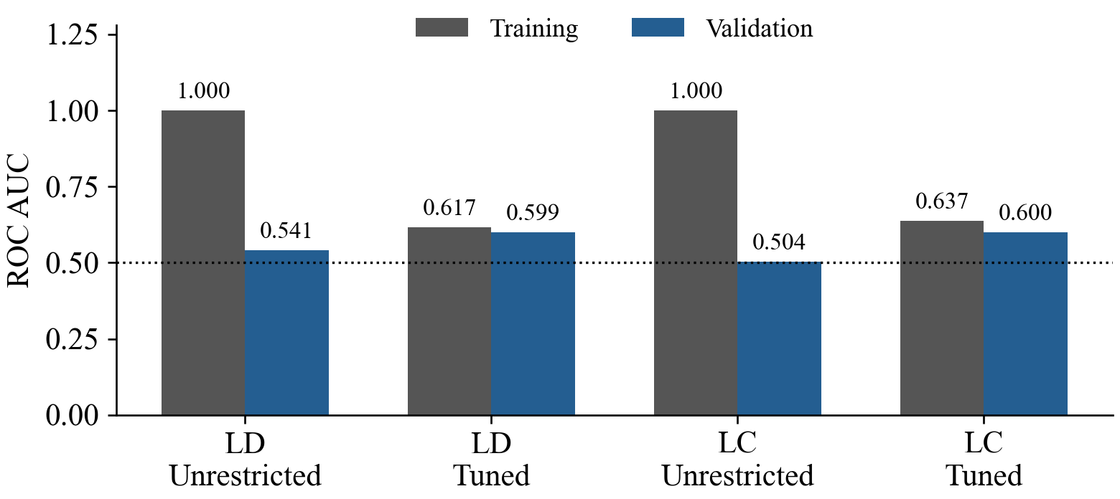
Figure 4. Unrestricted and tuned tree AUC. LD denotes Loan_Default and LC denotes LendingClub. Each loan split has 7,200 training and 2,400 validation rows. Source: Week 6.
Training CV crossed depth {2, 4, 8, unlimited}, leaf size {1, 10}, and ccp_alpha {0, 0.001}. Loan_Default selected depth cap 8, leaf size 1, alpha 0.001; pruning yielded actual depth 5 and eight leaves. Validation AUC rose from 0.542 to 0.599. LendingClub selected depth 4, leaf size 1, no pruning; validation AUC rose from 0.504 to 0.600. Unrestricted training AUC was 1.000 for both.
Figure 4 confirms expected overfitting: perfect training separation collapsed on validation, while constraints improved ranking. Tree thresholds need no standardization; fold-specific imputation and encoding still prevented preprocessing leakage. Truncating a displayed tree does not prune the fitted estimator.

Random forests help one loan task more than the other
Forests average 200 bootstrap trees and randomize split features to reduce correlation and variance. They cannot repair leakage. Training CV searched depth {4, unlimited}, leaf size {1, 10}, and features {square root, all}. Loan_Default selected unlimited depth; LendingClub selected depth 4. Both selected leaf size 10 and square-root features (scikit-learn developers, n.d.-f).
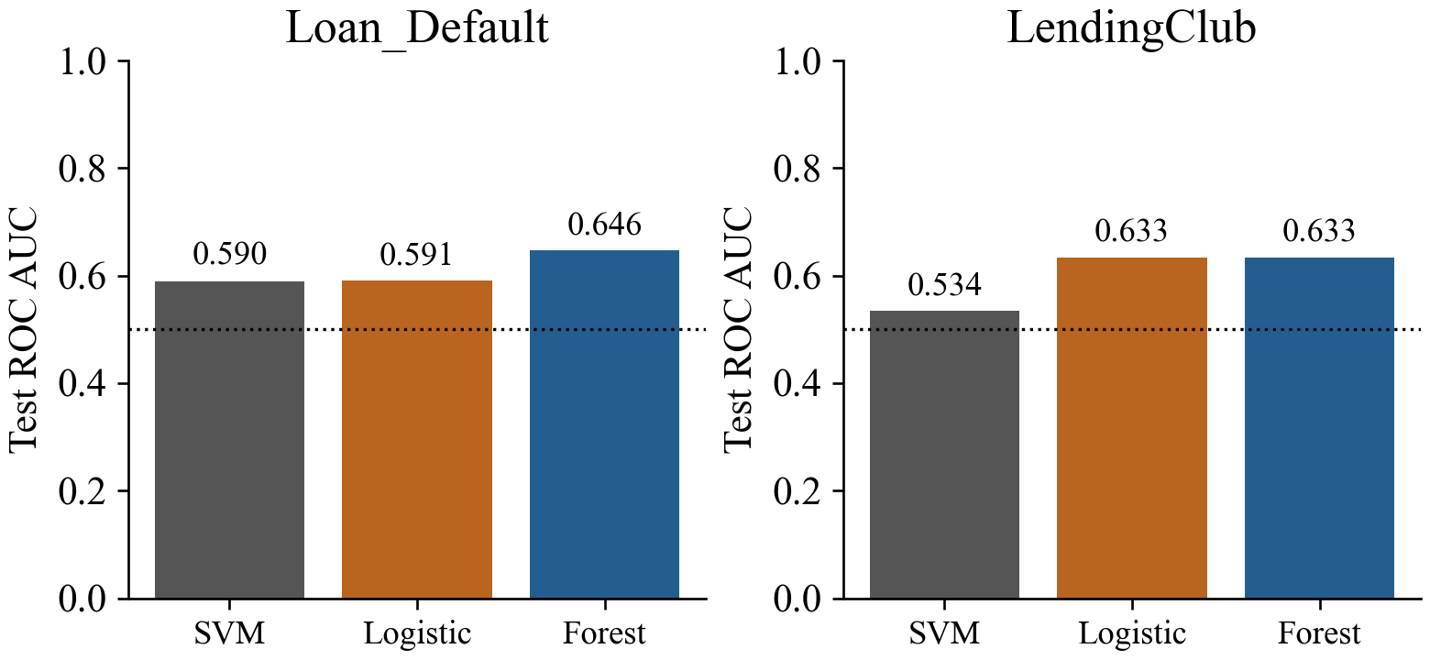
Figure 5. Matched test AUC across the selected Week 5 SVM, fixed-C logistic baseline, and selected Week 6 forest. Test n = 2,400 per dataset; dotted line = chance. Sources: Weeks 5–6.
The Loan_Default forest achieved AUC 0.646, AP 0.400, and F1 0.413 at its validation cutoff. Logistic AUC was 0.591. The forest’s conditional bootstrap AUC interval was [0.623, 0.673]; it describes uncertainty for the fitted model under row independence, excluding training and selection uncertainty. It is not a paired significance test against logistic. The observed improvement is promising within this restricted recorded-status task.
LendingClub forest AUC was 0.633, matching logistic to three decimals, with AP 0.221 versus 0.140 prevalence. F1 was 0.280 versus 0.246 for always positive. The forest’s AUC interval was [0.601, 0.662]. Thus the expected ensemble advantage was dataset-dependent. Comparing this result directly with Week 4 AUC 0.674 would confound algorithm changes with different samples and fitting procedures.

Small samples expose unreliable operating rules
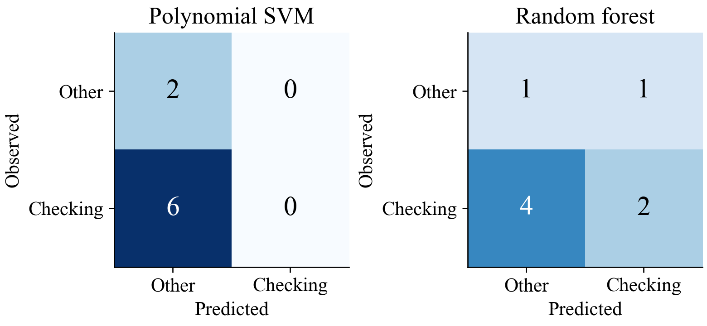
Figure 6. Bank test confusion counts at validation-selected cutoffs. Other means savings or CD. Each matrix contains eight records, including six checking accounts. Sources: Weeks 5–6.
Bank validation had two positives among seven records, whereas test had six among eight. The selected polynomial SVM’s AUC of 0.667 coexisted with F1 0 and six false negatives. The selected forest had validation AUC 0.700 but test AUC 0.417. It correctly identified two checking accounts, missed four, and falsely flagged one other account. Its AP of 0.813 must be read against 0.750 test prevalence, not as 81.3% accuracy. The forest’s F1 of 0.444 was far below an always-checking reference of 0.857.
This reversal was unexpected in direction but consistent with the instability expected from so few records. Group separation prevents account leakage; it cannot create adequate information. No reliable bank population interval or deployment claim follows. Regression also had negative test R² in every selected bank model. A model can beat the development-mean baseline yet have negative R² because R² uses the test-set mean as its reference.
Accuracy conceals minority errors. RMSE emphasizes large errors; MAE measures absolute error; R² uses a test-mean reference. Log loss evaluates probabilities, AUC ranking, and F1 a particular precision–recall tradeoff while ignoring true negatives. These metrics are complementary.

Conclusions and relevance to the capstone
LendingClub Week 1 reduced test RMSE from the development-mean baseline of 4.299 to 3.064 pp, a 28.7% reduction, with R² 0.492. Lasso barely changed error and PCR retained every component. A transparent pricing benchmark remains useful. Loan_Default’s 0.442 pp error describes observed-rate records, excluding nearly all Status 1 records; it cannot establish default prediction.
On matched samples, the forest outperformed fixed logistic ranking for Loan_Default; LendingClub forest and logistic tied to reported precision. SVM flexibility gave no consistent advantage. Held-out metrics and train–validation gaps support these findings. Historical comparisons require future-cohort validation, verified outcome timing, and cost-based cutoffs before lending decisions.
EDA changed eligibility, features, and evaluation. LendingClub’s maximum column VIF changed from 29.39 to 1.80 under equivalent categorical reference coding without changing OLS fits; VIF alone should not remove an entire predictor. Validation permutation importance ranked income first for the Loan_Default forest and FICO first for LendingClub. These indicate model reliance, not causality; correlated inputs can obscure importance (scikit-learn developers, n.d.-g).

References
Baker, C. (2026). DX799 weekly analyses [Jupyter notebooks, Weeks 1–6]. Local submission snapshot; repository: https://github.com/ckbaker78/Data-Science-Capstone-DX799
scikit-learn developers. (n.d.-a). Linear models. scikit-learn 1.8.0 documentation. https://scikit-learn.org/1.8/modules/linear_model.html
scikit-learn developers. (n.d.-b). Preprocessing data. scikit-learn 1.8.0 documentation. https://scikit-learn.org/1.8/modules/preprocessing.html
scikit-learn developers. (n.d.-c). Principal component regression vs partial least squares regression. scikit-learn 1.8.0 documentation. https://scikit-learn.org/1.8/auto_examples/cross_decomposition/plot_pcr_vs_pls.html
scikit-learn developers. (n.d.-d). Support vector machines. scikit-learn 1.8.0 documentation. https://scikit-learn.org/1.8/modules/svm.html
scikit-learn developers. (n.d.-e). Decision trees. scikit-learn 1.8.0 documentation. https://scikit-learn.org/1.8/modules/tree.html
scikit-learn developers. (n.d.-f). Ensembles and random forests. scikit-learn 1.8.0 documentation. https://scikit-learn.org/1.8/modules/ensemble.html#forest
scikit-learn developers. (n.d.-g). Permutation feature importance. scikit-learn 1.8.0 documentation. https://scikit-learn.org/1.8/modules/permutation_importance.html

Appendix A Weekly notebook completions
This appendix is outside the ten-page summary. The complete executed notebooks accompany this document in the Notebooks folder and the submission ZIP. They preserve code, saved outputs, figures, and original weekly instructions. The repository link is provided for navigation; local copies are the authoritative snapshot for the numbers in this report.
Full repository URL: https://github.com/ckbaker78/Data-Science-Capstone-DX799
Week 1 — Polynomial and interaction regression. Week 1.ipynb (also in the Notebooks folder).
Week 2 — Ridge lasso and elastic net. Week 2.ipynb (also in the Notebooks folder).
Week 3 — Group selection PCR and PLSR. Week 3.ipynb (also in the Notebooks folder).
Week 4 — Logistic regression and feature scaling. Week 4.ipynb (also in the Notebooks folder).
Week 5 — SVM kernels and regularization. Week 5.ipynb (also in the Notebooks folder).
Week 6 — Decision trees and random forests. Week 6.ipynb (also in the Notebooks folder).
Reproduction: place the three original CSVs in the repository DATA folder, install requirements-notebooks.txt, and use Restart Kernel → Run All in each notebook. Saved execution used Python 3.13.5 and scikit-learn 1.8.0. Original datasets are not redistributed in the submission ZIP. All six notebooks are tracked in the repository at commit 396b3d1, which matches the locally recorded origin/main. The included copies preserve the exact saved outputs used here.

Appendix B AI use and source discussion
OpenAI Codex substantially assisted this submission: reading the rubric, inspecting saved notebook outputs, drafting and revising prose, generating comparison figures, checking external documentation, and building and visually checking the Word document. AI contributed report text and preparation code; this is not an independently written student narrative.
The user request was to read the MOD C Milestone One PDF and complete the assignment against its rubric. No new model-performance results were invented for this report. The report preparation reused saved notebook results; the six modeling notebooks were not rerun as part of preparing this summary. The dates and exact scope of any earlier AI assistance with those notebooks are not established here. This disclosure describes the assistance observed during report preparation.
The author should verify interpretations and compliance with course AI policy. No course submission, GitHub push, or YellowDig posting was performed in this task. The rubric expects external sources to be shared and discussed on YellowDig; local files cannot establish that participation.

Prepared discussion for YellowDig
The scikit-learn SVM guide helped explain why kernel flexibility and a useful decision rule are separate. My LendingClub RBF fit had training AUC 0.857 but validation AUC 0.525. A linear SVM cutoff then generated 1,724 false positives on test. The tree guide provides a contrasting example: constraining a LendingClub tree raised validation AUC from 0.504 to 0.600. How would you separate class weighting, regularization, and cutoff selection while preserving a genuinely fresh final holdout? Sources: references d and e. This is prepared discussion text, not evidence of participation.

